**Useful Information and List of Phrases for**

**the Course *Business E-communication in English***

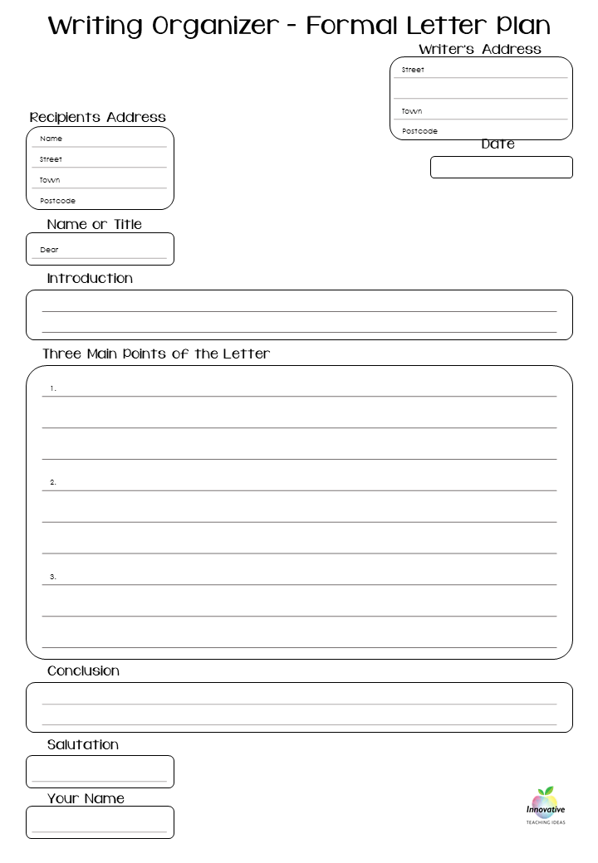

***Parts of a letter/email***

GREETING.

In formal letters/emails you can use different greetings but you should be careful what to use:

- when you don’t know the recipient’s name, you have to use ***Dear Sir/Madam,***but it is still common to use the old-fashioned ***To Whom It May Concern;***

- when you know the recipient’s name, use ***Dear* *Mr Davis.***

*e.g. If you write to the President of the Committee on Democracy and Human Rights of Inter-Parliamentary Union, you should start you letter with* ***Dear Mr Desai.***

BODY OF LETTER

* The *first paragraph* of your letter should provide an introduction as to why you are writing so that your reason for contacting the person is obvious from the beginning.
* Then, in the *following paragraphs,* provide specific details about your request or the information you are providing.
* The *last paragraph* of your letter should reiterate the reason you are writing and thank the reader for reviewing your request. If appropriate, it should also politely ask for a written response or for the opportunity to arrange a meeting to further discuss your request.

BODY OF EMAIL

There are no conventional formulas for writing the body of the text because this varies according to the function of what you need to communicate. It’s useful to prepare an initial draft and then proceed with any corrections.

ENDING/CLOSING

. Ending is not an easy thing either. You should remember that:

- when you begin with ***Dear Mr/Mrs/Ms Davis,*** you should end with ***Yours sincerely + your full name;***

- when you begin with ***Dear Sir/Madam*** or ***To Whom it May Concern***, you should end with ***Yours faithfully + your full name***;

- in semi-formal/neutral letters you may use ***Regards / With kind regards / Best regards / Yours truly / Sincerely.***

*e.g. You write a letter to the President of the Committee on Democracy and Human Rights of Inter-Parliamentary Union, Mr Desai****,*** *so you have to finish your letter with* ***Yours sincerely.***

***Example of a letter***

*If you are writing a letter to the President of the Committee on Democracy and Human Rights of Inter-Parliamentary Union.*

*Your Address*

November 30, 2020

A.I. Desai

President

Committee on Democracy and Human Rights

Inter-Parliamentary Union

5, chemin du Pommier

Case postale 330

CH-1218 Le Grand-Saconnex, Geneva

Switzerland

Dear Mr Desai,

I am writing …. *(Body of your letter)*

Yours sincerely,

*Your signiture*

*Your name*

***Example of an email***

*e. g. You want to clarify some points about the* *next ENVI Committee meeting (Committee on Environment, Public Health and Food Safety) which will take place on the 1st December, 2020. You have to write an email.*

*Address*: sarah.blau@europarl.europa.eu

*Subject:* the next ENVI Committee meeting

Dear Ms Blau,

I am writing in response to … *(Body of your email)*

Yours sincerely,

*Name*

*Position*

*Department*

*V*erhovna Rada of Ukraine

11 vul. Velika Zhytomyrska

Kyiv, 02000

Tel.: +38(044) 255 4246

Fax:+38(044) 255 4246

Emai: ...

**Useful phrases for formal letter/email writing**

*Starting*

* We are writing to inform you that ...

to confirm ...

to request ...

to enquire about ...

* I am contacting you for the following reason.
* I recently read/heard about . . . and would like to know . . .
* Having seen your advertisement in ... , I would like to ...
* I would be interested in (obtaining/receiving) ...
* I received your address from … and would like to ...
* I am writing to tell you about ...

*Referring to previous contact*

* Thank you for your letter of March 15 ...
* Thank you for contacting us.
* In reply to your request ...
* Thank you for your letter regarding ...
* With reference to our telephone conversation yesterday ...
* Further to our meeting last week ...
* It was a pleasure meeting you in London last month.
* I enjoyed having lunch with you last week in Tokyo.
* I would just like to confirm the main points we discussed on Tuesday . . .

*Making a request*

* We would appreciate it if you would ...
* I would be grateful if you could...
* Could you please send me . . .
* Could you possibly tell us/let us have...
* In addition, I would like to receive ...
* It would be helpful if you could send us ...
* I am interested in (obtaining/receiving...)
* I would appreciate your immediate attention to this matter.
* Please let me know what action you propose to take.

*Offering help*

* We would be happy to ...
* Would you like us to ...
* We are quite willing to ...
* Our company would be pleased to ...

*Giving good news*

* We are pleased to announce that ...
* I am delighted to inform you that ...
* You will be pleased to learn that ...

*Giving bad news*

* We regret to inform you that ...
* I'm afraid it would not be possible to ...
* Unfortunately we cannot/we are unable to ...
* After careful consideration we have decided (not) to ...

*Complaining*

* I am writing to express my dissatisfaction with ...
* I am writing to complain about ...
* Please note that the goods we ordered on (date) have not yet arrived.
* We regret to inform you that our order n°--- is now considerably overdue.
* I would like to query the transport charges which seem unusually high.

*Apologizing*

* We are sorry for the delay in replying ...
* I regret any inconvenience caused
* I would like to apologize for (the delay/the inconvenience) ...
* Once again, I apologise for any inconvenience.

*Enclosing/Attaching documents*

* I am enclosing / attaching ...
* Please find enclosed / attached...
* You will find enclosed / attached…

*Closing remarks*

* If we can be of any further assistance, please let us know
* If I can help in any way, please do not hesitate to contact me
* If you require more information ...
* For further details ...
* Thank you for taking this into consideration
* Thank you for your help.
* We hope you are happy with this arrangement.
* We hope you can settle this matter to our satisfaction.

*Referring to future business*

* We look forward to a successful working relationship in the future
* We would be (very) pleased to do business with your company.
* I would be happy to have an opportunity to work with your firm.

*Referring to future contact*

* I look forward to seeing you next week
* Looking forward to hearing from you

to receiving your comments

* I look forward to meeting you on the 15th
* I would appreciate a reply at your earliest convenience.
* An early reply would be appreciated.