**Useful Information and List of Phrases for**

**the Course *Planning and Preparing Presentations***

**STAGES OF A PRESENTATION**

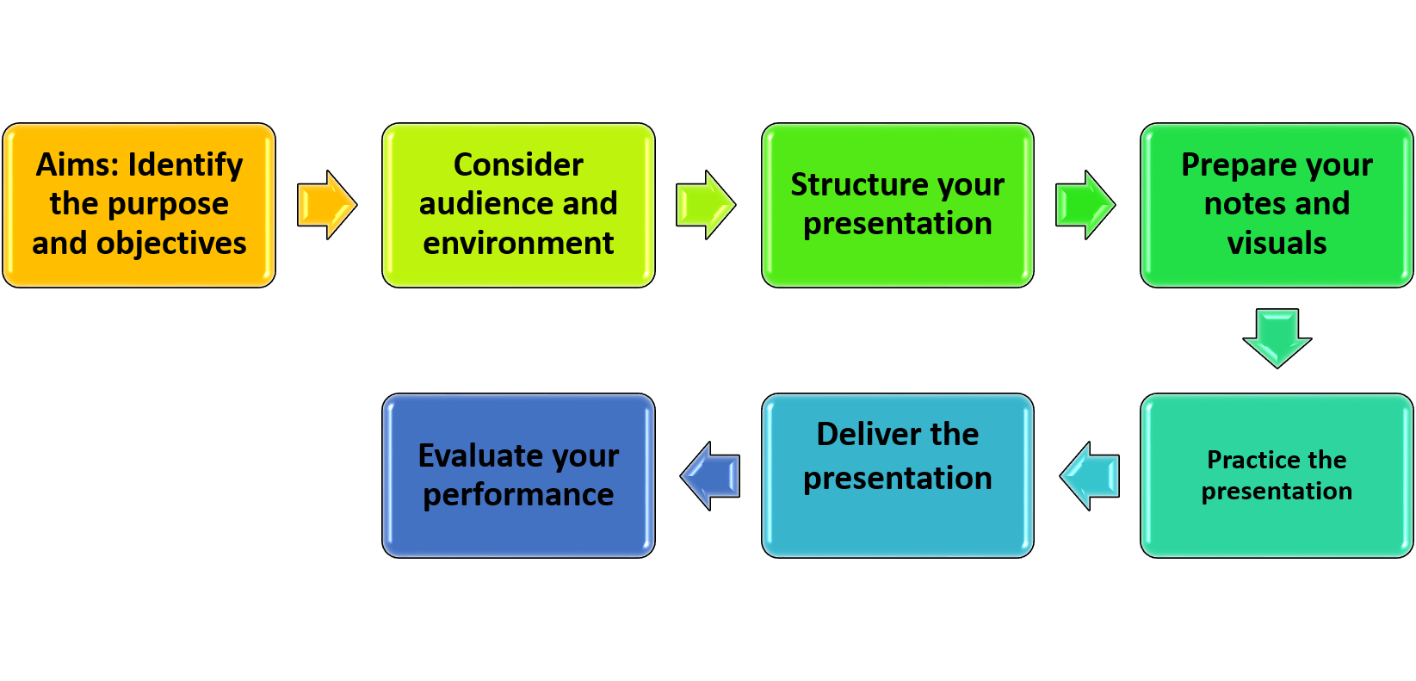

**STRUCTURE OF A PRESENTATION**

**Introduction**

Background

Main Idea

**II. Body**

**Main Point One**

Supporting detail A

Supporting detail B

**Main Point Two**

Supporting detail A

Supporting detail B

**Main Point Three**

Supporting detail A

Supporting detail B

**III. Conclusion**

How this relates to the bigger picture

Why my research is important

**USEFUL PHRASES**

***Introduction***

* Greet your audience. Say who you are and why you are giving this presentation (Phrases for greeting:

Good morning, ladies and gentlemen!

Good morning/afternoon/evening, everyone!

Hello everyone, I’m delighted to be speaking with you today.

Hello and thank you all for coming. I appreciate you being here *on* *such a rainy Monday morning / last thing on a Friday afternoon.*

Phrases of introduction:

Welcome to [name of event].

First, let me introduce myself. I am [name] from [institution]

To introduce myself, my name is [name] and I am [position].)

* Say what the presentation is about and what your objectives are

(Phrases to begin your presentation:

### Let me start by giving you some background information.

As you’re aware, …

As you all know, I am going to be talking to you about …

In this presentation, I am going to walk you through …

For the next *forty-five minutes*, I am going to be speaking to you about …

By the end of this session, you will all know a little more about ...)

* Give an overview of the main ideas/main parts

(Important phrases:

My presentation will take about *45* minutes and is divided into *four* sections. Section 1 is going to discuss…

Since we only have 45 minutes to discuss this huge topic, I’m going to keep things brief. This talk will be divided into *four* sections. To start off…

I thought it would be helpful to share a road map of what I’m planning to cover. This talk will be divided into *four sections.*

I’m going to look at four different aspects of ...

* Opening attention grabber ( a quotation, a joke, a little known and striking fact, a statement of opinion that you intend to challenge, an interesting incident or anecdote related to your subject.)

***Main body***

* Order your information in a logical way

Phrases of transitioning to the new topic:

### Let’s move on to…

Turning our attention now to…

First, I’d like to start …

Secondly,….

Next ….

Then …

After that ...

In addition, …

Finally, …..

Phrases to provide more details:

I’d like to expand on…

 Let me elaborate further.

* Follow the overview you gave at beginning

Phrases to link to another topic:

As I said at the beginning, …

This relates to what I was saying earlier…

This ties in with…

Phrases to emphasis the point:

The significance of this is…

This is important because…

We have to remember that …

Phrases to make reference to the information:

Based on our findings, …

According to statistics, …

Our data shows …

* Use examples & quality sources to illustrate your points

Phrases to provide examples:

I’d like to illustrate this point by showing you…

For example, …

For instance, ...

***Conclusion***

* Summarise your key points and remind about advantages, solutions, options and conclusions

Phrases to summarise your key points:

### In conclusion, let me sum up my main points.

That’s it on *…* for today. In brief, we’ve covered …

Well, that’s just about all we’ve got time for today, unfortunately. I hope you have learned something about …

Well, that concludes my presentation today. To refresh your memory, the main takeaways are the following. Number one…

That brings me to the end of my presentation. I hope you’re a little clearer on ...

So to draw all that together, next time you think about, consider the following factors…. That’s all from me!

* Invite questions

Phrases to involve the audience in the discussion:

Thank you for listening. We have *five minutes* left over. Are there any questions?

Thank you for your attention, I hope you’ve found this session useful. I’d be happy to answer any questions.

Thank you for listening. I’d now like to open up the floor to questions, so just raise your hand if there’s anything else you want to know.

Thank you for your question*.*

That’s an interesting question.

I’m glad you asked me that.

I hope that makes sense. Is that the kind of answer you were looking for?

Does that answer your question?

Feel free to come and grab me afterward if you want to discuss this further.

* Thank audience for their attention

Phrases to thank the audience:

Thank you very much for your attention.

Thank you all for coming, I really enjoyed speaking to you today and hope this session has been useful.

Thanks for listening, do feel free to contact me via my website or email if you think of any further questions.)

**VISUALS**

# When you prepare your visual or PowerPointPresentation (ppt.) you should remember the following points:

* Use simple text and graphics
* Use consistent colours/theme
* Don’t crowd too much information on one slide
* If you have text on the screen, read it or leave time for audience to read it

# *Language to describe visiual aids:*

* As you can see…
* If you look at it more closely, you’ll notice…
* Note the reasons for this…
* I’d like us to look at this part of the graph in more detail.
* Please place your attention on one particularly important feature.
* I’d like you to think about the significance of the figure here.
* I’d like to point out one or two interesting details.
* I’d like to draw your attention to the upper half of the chart.
* From the data it can be inferred that …
* According to figure 2, …
* This graph indicates…
* Given this, it’s obvious that …
* As this bar chart shows, …